I took an online class through Johns Hopkins called “How to Use Digital Content in Your Classroom”.
In this self-paced instructional course, we learned the specifics of capturing, transferring, and editing digital images and video. In addition, we learned to create instructional products integrating those media through practical applications that are transferable to the classroom. As a result of this course, I walked away with a lesson plan that integrates original digital images I took and a video I record, as well as a digital portfolio of my work. I also left this course with additional ideas for how to integrate the use of digital images and video into my teaching and learning environment.
Course Grades:
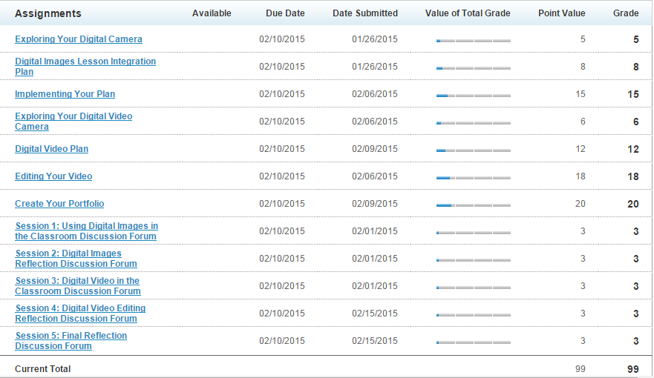

Lesson Plan(s):
Digital Images Integration Plan
Lesson Title: My Digital Life
Subject: Library Media
Grade Level: 6
Objectives of the lesson:
I will be able to…
- learn about the 24/7, social nature of digital media (Past and Present)
- explore my digital life
- learn that it is important to act responsibly when carrying out relationships over digital media
- create a simile to express my digital life and express it using digital images

Describe the lesson that you are going to add digital photographs to:
Students are learning about how media impacts their lives and the world around them. We will explore how digital life is a 24/7 social nature in today’s society compared to culture’s past. We will compare and contracts present life to another decade. I will use pictures to show examples and comparisons. Student for a final project will create a simile about their digital life and then use pictures to express the simile.
What | Where | Why | How
Photo 1:  picture of different types of technologies used (cellphone, tablet, laptop, etc) | Used within a powerpoint to introduce/teach background information | Visually stimulate and draw on prior knowledge; help express examples of different forms of technologies used in digital life | Questions students: on how each example is part of a digital life, which one influences a digital life more than another? Students will watch video at: http://tinyurl.com/kaatrkz
Photo 2:  Calendar | Used within my video for simile example | This is will be used for the example video for the students to observe. The end project for the students create a simile about their digital life and then use pictures to express the simile | After learning about digital lives and participating in discussion forums, students will read my simile and observe my video example. My simile: “My digital media life is like a calendar because without my phone, computer, etc I wouldn’t be able to keep track of my family’s life.” (See below for simile prompt)
Photo 3:  Photo of Family | Used within my video for simile example | This is will be used for the example video for the students to observe. The end project for the students create a simile about their digital life and then use pictures to express the simile | After learning about digital lives and participating in discussion forums, students will read my simile and observe my video example. My simile: “My digital media life is like a calendar because without my phone, computer, etc I wouldn’t be able to keep track of my family’s life.” (See below for simile prompt)
Photo 4:  Photo of time pieces | Used within my video for simile example | This is will be used for the example video for the students to observe. The end project for the students create a simile about their digital life and then use pictures to express the simile | After learning about digital lives and participating in discussion forums, students will read my simile and observe my video example. My simile: “My digital media life is like a calendar because without my phone, computer, etc I wouldn’t be able to keep track of my family’s life.” (See below for simile prompt)
Photo 5:  Photo of Family | Used within my video for simile example | This is will be used for the example video for the students to observe. The end project for the students create a simile about their digital life and then use pictures to express the simile | After learning about digital lives and participating in discussion forums, students will read my simile and observe my video example. My simile: “My digital media life is like a calendar because without my phone, computer, etc I wouldn’t be able to keep track of my family’s life.” (See below for simile prompt)

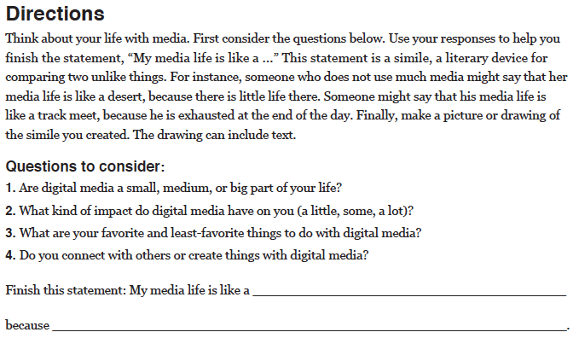

(*above credit: Common Sense Media)

Key Points
What: List the photos that you will take and will incorporate into your lesson. What will the images reference in the lesson?
Where: Describe where you are going to incorporate the digital photographs in the lesson.
Why: Explain why you are going to add digital photos to this lesson. You may reference the readings.
How: Provide an outline of how you are going to introduce the content and photos in the lesson. Include any extension activities that will accompany the clips.

Digital Video Plan Storyboard and Template
Lesson Title: Got Media Smarts??
Subject: Library Media
Grade Level: 6th
Objectives for the lesson:
Students will be able to…
- learn about the 24/7, social nature of digital media (Past and Present)
- explore my digital life
- learn that it is important to act responsibly when carrying out relationships over digital media
- create a simile to express my digital life and express it using digital images

Briefly describe the video you will create and the context you will use it for your lesson.
Students are learning about how media impacts their lives and the world around them. We will explore how digital life is a 24/7 social nature in today’s society compared to culture’s past. We will compare and contracts present life to another decade. This video is titled “Got Media Smarts?” is shows adults from within our school being quizzed on questions about digital media in the past and digital m. This video will be used as an introduction to out discussion on how digital media has changed over the years. 3 staff members will be asked questions and then provide and answer. Following each staff member a fact or answer will be shown.
Title Shot: Background music during entire video (fade in and out when others talk)  Shot 1 | Intro Shot:  Students and Staff Face Off!!  Find out who is the bigger master of media.  Shot 2
Shot 3  Mr. Atkinson video game question  (shot of teacher with question being read out loud and then teacher answering it) | Shot 4  Atari answer and fact  (words only)
Shot 5  Mrs. Carr with which media did they watch the most (shot of teacher with question being read out loud and then teacher answering it) | Shot 6  TV followed by music, computers and video games.  (words only)
Shot 7  Mrs. Morgan with how many views for YouTube (shot of teacher with question being read out loud and then teacher answering it) | Shot 8  Over 1 Billion  (words only)
Shot 9  Scrolling words thanking participants  (words only) | Shot 10  Closing credit with Directed by Mrs. Lemmo

Shooting Script Template
Shooting Script Title:
Shot | Description
Shot 1 | Title: Got Media Smarts - Text
Shot 2 | Students and Staff Face Off!! Find out who is the bigger master of media.
Shot 3 | Mr. Atkinson: Q1 – What was the first home video game console sold in the US?
Shot 4 | Atari 2600 fact
Shot 5 | Mrs. Carr – Q2 – In 2009, kids ages 11-14 spent the most time with this type of media
Shot 6 | Order of Media
Shot 7 | Mrs. Morgan - Q3 – As of late 2009, approximately how many views did YouTube get each day?
Shot 8 | Over 1 Billion
Shot 9 | Thank Yous
Shot 10 | Direct by Mrs. Lemmo

My video “ Got Media Smarts??” can be found at the following link:
http://youtu.be/fHE4apkuMqo

I used the online presentation program called emaze to make my portfolio
You can view my presentation at:
http://app.emaze.com/@AOZOFOCI/digital-life-101

